Geometry Contract: Tower A

Version: 1.0
Applies to: All Tower A electric-field simulations for thalamic microstimulation

Table of Contents
1. Purpose and Scope 1
1.1 Purpose 1
1.2 Scope. 1
2. Coordinate System & Units 1
2.1 Right-handed RAS frame. 1
2.2 Origin. 2
2.3 Units. 2
3. Governing Model 2
3.1 PDE (quasi-static conduction): 2
3.2 Current density and sign. 2
4. Domain Definition (Ω) 3
4.1 Shape. 3
4.2 Numerical extents (default). 3
4.3 Embedded conductors. 3
5. Material Properties (σ) 3
5.1 Base assumption (L0 and L1-HOM). 3
5.2 Heterogeneous/anisotropic option (L1-HET). 3
5.3 Units and scaling. 4
6. Contact Patch Specifications (Γₑ) 4
6.1 Simple (L0) — Single contact 4
6.2 Scalable (L1) — M×N grid (default 2x8 = 16) 4
7. Reference / Gauge Patch (Γ₀) 5
7.2 Definition (default). 5
7.3 Alternative. 5
8. Current Balance Rule 6
8.1 Global balance : 6
8.2 Monopolar configuration 6
8.3 Bipolar configuration. 6
9. Outer Boundaries (Γ_out) 6
9.1 Faces and normals. 6
9.2 Default treatment. 6
9.3 Optional symmetry faces. 7
10. Sampling Strategy (for PINN collocation) 7
10.1 Interior (Ω) points. 7
10.2 Contact patches (per Γₑ). 7
10.3 Outer boundaries (excluding Γ₀). 7
10.4 Gauge patch Γ₀. 7
10.5 Multi-fidelity (optional 7
11. Default Numeric Values (summary) 7
12. Implementation Mapping (informative, non-binding) 8
12.1 Domain. 8
12.2 Boundary conditions. 8
12.3 Units. 8
13. Sanity / Validation Checklist (execute before each run) 8
14. JSON Schema example 9
15. Notes on Scaling Up with Minimal Change 11
16. Change Control (initial baseline) 12
Appendix A — Quick Reference of Symbols 12
Appendix B — Rationale for Defaults (informative) 12

1. Purpose
This document fixes the spatial, physical, and boundary agreements for Tower A. It is the reference point for how the geometry, coordinates, materials, and boundaries are represented when solving the volume conduction problem for microstimulation.

2. Coordinate System & Units

2.1 Right-handed RAS frame.
x: Left → Right (positive to patient’s right).
y: Posterior → Anterior (positive anterior).
z: Inferior → Superior (positive superior).
2.2 Origin.
The origin (0, 0, 0) is at the center of the active array footprint projected onto the electrode–tissue interface plane (the “array plane”). For single-contact L0, the origin is the center of the single contact.

2.3 Units.
Length: millimeter (mm) for all coordinates in inputs/outputs and for patch dimensions.
Potential: volt (V).
Current: ampere (A).
Conductivity: siemens per meter (S/m).
Internal scaling: when evaluating PDE operators, convert mm→m using κ = 1e−3 m/mm. Areas computed from mm must be multiplied by κ². (because of S/m)

3. Governing Model

3.1 PDE (quasi-static conduction):
$$∇⋅\left(σ∇ϕ\right)=0 \text{in }Ω$$
$ϕ$the electric potential (V),
$σ$the tissue conductivity (S/m).
3.2 Current density and sign.
Define current density $J=-σ ∇ϕ$ (A/m²).
Let $n$ be the outward unit normal to Ω at a boundary. The Neumann is expressed as
$$j_{n} =def - σ∇ϕ⋅n=J⋅n.$$
Convention: $j_{n}>0$means net current enters the tissue through that boundary patch (inward flux).

4. Domain Definition (Ω)
4.1 Shape.
Rectangular box (axis-aligned).
4.2 Numerical extents (default).
Length is given by: $L_{x}=L_{y}=L_{z}=12\text{ mm}$.
Then domain: $Ω=[-L_{x}/2, L_{x}/2]×[-L_{y}/2, L_{y}/2]×[-L_{z}/2, L_{z}/2].$
Rationale: Keep outer boundaries far enough to limit truncation artifacts in monopolar mode (see §8 and §11). Adjust if needed.
4.3 Embedded conductors.
Ω contains only biological tissue. Electrodes are excluded volumes (solid conductors) whose tissue-facing caps are boundary patches Γₑ (see §6). The default shank model is a cylinder of radius $r_{\text{shank}}$with its tip flush with the array plane.

5. Material Properties (σ)

5.1 Base assumption (L0 and L1-HOM).
Homogeneous isotropic conductivity
$$σ_{\text{tissue}}=0.20\text{ S/m (default)}.$$
5.2 Heterogeneous/anisotropic option (L1-HET).
Replace $σ_{\text{tissue}}$by a piecewise constant or symmetric positive-definite tensor field $σ(x)$.
σ = σ(x)
Each subdomain must declare: name, $σ$(scalar or 3×3 SPD), and region bounds. If anisotropy is used, specify the principal axes relative to the RAS frame.

5.3 Units and scaling.
All σ values are in S/m and used directly in PDE evaluation (recall mm→m scaling in differential operators per §2.3).

6. Contact Patch (Γₑ)
Each electrode contact $e$declares the following fields:
- Name: E<row><col>
- Patch type: planar circular cap (default) or hemispherical cap.
- Plane & normal: array plane is z = zₐ with normal +z pointing into tissue.
- Center (mm): $(x_{e},y_{e},z_{e})$in the global frame; for planar tips, $z_{e}=z_{a}$.
- Radius (mm): $r_{e}$(default 0.025 mm = 25 μm).
- Area (mm²): $A_{e}=πr_{e}^{2}$.
- Boundary type:
  - Neumann (current-controlled): impose $j_{n,e}$[A/m²] on Γₑ.
  - Dirichlet (voltage-controlled): impose $ϕ=ϕ_{e}$on Γₑ.
- Current direction convention: $j_{n,e}>0$injects charge into Ω.
- Electrode body: excluded cylinder of radius $r_{\text{shank}}$(default 0.05 mm), axis along +z, whose tip cap is Γₑ.
- Electrode–tissue interface assumed perfectly conducting

6.1 Simple (L0) — Single contact
- Array plane: $z_{a}=0$.
- Contact: E01 at $(0,0,0)$, $r_{E01}=0.025$ mm, Neumann by default.
- Mode: Monopolar (uses Γ₀ as remote return; §7).

6.2 Scalable (L1) — M×N grid (default 2x8 = 16)
Coordinate derivation for 2 × 8 grid, let :
M = 2 (rows along y),
N = 8 (columns along x),
pitch p = 0.40 mm,
zₐ = 0,
rₑ = 0.025 mm.
Then contact centers are:
$$x_{i}=\left(i-\frac{N+1}{2}\right)p,$$
$$y_{j}=\left(j-\frac{M+1}{2}\right)p,$$
$$z=z_{a}$$
For $i=1..N, j=1..M$.
Modes: Monopolar (some subset active; remote return via Γ₀) or Bipolar (paired Neumann contacts with equal/opposite currents; §8).

7. Reference / Gauge Patch (Γ₀)
Because the electric potential ϕ is only defined up to an arbitrary constant, we must fix its reference somewhere. We do this by assigning a small surface called Γ₀ (Gamma-zero), where the potential is set to ϕ = 0. This reference makes the solution unique. In monopolar stimulation mode, Γ₀ also acts as the remote return electrode: it collects the same amount of current that the active contact injects, closing the electrical circuit through the surrounding tissue.
7.2 Definition (default).
Circular disc on the +z outer face at $(0,0,L_{z}/2)$with radius $r_{0}=1.5$ mm.
Boundary condition: $ϕ=0$on Γ₀ (Dirichlet).
Remaining area of that face: treated per §9 (insulating unless otherwise declared).
7.3 Alternative.
For all-bipolar operation, Γ₀ can be shrunk to a point (gauge) with no physical role; use a tiny (≤0.1 mm) patch with $ϕ=0$solely for gauge fixing.

8. Current Balance

8.1 Closed system balance:
$$\sum_{e=1}^{N_{e}}{I_{e}}+\int_{Γ_{\text{out}}}{j_{n} }dA=0,$$
$$I_{e}=\int_{Γ_{e}}{j_{n,e}} dA.$$
8.2 Monopolar configuration.
Γ₀ is Dirichlet; flux through Γ₀ adjusts implicitly to satisfy balance. All remaining outer faces are insulating (no net flux). Do not set all boundaries to Neumann if any $I_{e}≠0$; that is ill-posed.
8.3 Bipolar configuration.
For any active pair (e⁺, e⁻), enforce
$$I_{e^{+}}+I_{e^{-}}=0\text{(wi}\text{th }\text{tolerance)}.$$
Γ₀ is retained for gauge but may carry negligible flux.

9. Outer Boundaries (Γ_out)

9.1 Faces and normals.
Outer walls need to be far enough away from the active contacts to:
- Let the field decay naturally
- Avoid clipping important gradients
  - they don’t physically reflect the brain boundary
The rectangular box domain
$$Ω=[-\frac{L_{x}}{2}, \frac{L_{x}}{2}]×[-\frac{L_{y}}{2}, \frac{L_{y}}{2}]×[-\frac{L_{z}}{2}, \frac{L_{z}}{2}]$$
Enclosed by six outer faces (Γ_out) located at
$$\begin{matrix}x & =±\frac{L_{x}}{2}, \\ y & =±\frac{L_{y}}{2}, \\ z & =±\frac{L_{z}}{2}.\end{matrix}$$
Each of those planes spans the entire side of the box.
Outward normals follow the RAS axes.

Face | Equation | Outward normal ({n} ) | Meaning
+X | (x = +L_x/2) | (+ {x}}) | right face
−X | (x = -L_x/2) | (− {x}}) | left face
+Y | (y = +L_y/2) | (+ {y}}) | anterior face
−Y | (y = -L_y/2) | (− {y}}) | posterior face
+Z | (z = +L_z/2) | (+ {z}}) | superior (top) face
−Z | (z = -L_z/2) | (− {z}}) | inferior (bottom) face
Each face is part of Γ_out, unless overridden by:
- the Dirichlet disc Γ₀ on the +Z face,
- or electrode patches Γₑ inside the box (on z = 0).
Everywhere else:
$$-σ∇ϕ⋅n=0\text{(homogeneous Neumann, insulating)}$$

9.2 Default treatment.
Γ₀ portion of $z=+L_{z}/2$: Dirichlet $ϕ=0$(remote return).
All remaining outer faces (including the rest of $z=+L_{z}/2$and the entire $z=-L_{z}/2$, ±x, ±y): Insulating (homogeneous Neumann)
$$j_{n}=-σ∇ϕ⋅n=0.$$

9.3 Optional symmetry faces.
When activating symmetry, declare the plane and ensure the contact set respects that symmetry; then use homogeneous Neumann on the symmetry face(s).

10. Sampling Strategy (for PINN collocation)
(Optional defaults for stable training; scale with problem size.)

10.1 Interior (Ω) points.
Base count:
$N_{Ω}=50,000$, scalable to ≥200,000 for L1 or heterogeneous conductivity models.
Strategy:
Points drawn using a multi-shell, log-radial sampling scheme centered on each electrode tip.
Shell layout:
Radial distances: log-spaced from 10–20 μm to 1–2 mm
Points per shell: uniformly distributed over each spherical shell
Supplemental background:
A light uniform or Latin hypercube background (e.g., ~5–10k points) ensures global coverage beyond local fields.

10.2 Contact patches (per Γₑ).
$N_{Γ_{e}}=max⁡\text{ ⁣}(2000,⌈200 A_{e}/(0.01 {\text{mm}}^{2})⌉)$. Uniform on the disc, with anti-alias jitter.

10.3 Outer boundaries (excluding Γ₀).
$N_{Γ_{\text{out}}}=10,000$across all insulating faces, distributed proportional to face area.

10.4 Gauge patch Γ₀.
$N_{Γ_{0}}=5000$(Dirichlet points).

10.5 Multi-fidelity (optional)
Bias additional Ω points to high-gradient regions using residual-based re-sampling between epochs.

11. Default Numeric Values (summary)
$L_{x}=L_{y}=L_{z}=12$ mm; array plane $z_{a}=0$.
$p=0.40$ mm (L1 pitch), $r_{e}=0.025$ mm, $r_{\text{shank}}=0.05$ mm.
Γ₀: disc at $(0,0,L_{z}/2)$, $r_{0}=1.5$ mm, $ϕ=0$.
$σ_{\text{tissue}}=0.20$ S/m (L0/L1-HOM).
Positive $j_{n}$injects current into tissue.

12. Implementation Mapping

12.1 Domain.
Represent Ω as a Cartesian box. Exclude electrode cylinders; their tip caps define Γₑ interior boundaries.

12.2 Boundary conditions.
- Neumann (current): Evaluate residuals with imposed $j_{n,e}$on Γₑ.
- Dirichlet (potential): Fixed value residuals on Γ₀.
- Insulating: homogeneous Neumann on remaining Γ_out faces.

12.3 Units.
Keep all geometry in mm at the interface but convert to SI for PDE operators (κ scaling per §2.3).

13. Sanity / Validation Checklist (execute before each run)
Coordinates & orientation
- Axes follow RAS; outward normals point to +x, −x, +y, −y, +z, −z appropriately.
- Array plane is at $z=z_{a}$; contact centers sit on that plane.
Patch inclusion & spacing
- All Γₑ are inside Ω (disjoint from Γ_out) with $z_{e}=z_{a}$.
- Minimum padding from any contact edge to the nearest outer face is ≥ 10 × r_e and ≥ 5 × p (or ≥ 2.0 mm, whichever larger) to limit boundary influence.
Units & scaling
- Radii/lengths in mm; S/m for σ; A for currents.
- mm→m conversion applied inside differential operators.
Flux & current balance
- For monopolar: with $I_{\text{inj}}=∑I_{e}$, measured net flux through Γ₀ equals $-I_{\text{inj}}$within tolerance.
- For bipolar: pairwise $I_{e^{+}}+I_{e^{-}}≈0$.
- No non-zero Neumann patches exist without either (i) a Dirichlet segment or (ii) paired opposite-sign Neumann(s).
Boundary BCs
- Γ₀ present and $ϕ=0$applied.
- All non-Γ₀ outer faces have $j_{n}=0$unless explicitly declared symmetry/return.
Contact definitions
- Each Γₑ declares (name, center, radius, area, BC type, current sign).
- Neumann $j_{n,e}$integrates to requested $I_{e}$using SI area (m²).
Material
- σ is positive (scalar) or SPD (tensor); piecewise regions do not overlap.
- If anisotropy is used, principal axes specified in the RAS frame.
Reproducibility
- Seed, sampling counts, and geometry JSON (see §14) are logged with the model checkpoint.

14. JSON Schema example
A minimal machine-readable schema to describe both L0 and L1 (excerpt):
{
"frame": "RAS",
"units": {"length": "mm", "sigma": "S/m", "potential": "V"},
"domain": {
"type": "box",
"extents_mm": {"Lx": 12.0, "Ly": 12.0, "Lz": 12.0},
"array_plane_mm": {"z": 0.0}
},
"materials": [
{"name": "tissue", "type": "isotropic", "sigma_S_per_m": 0.20, "region": "all"}
],
"electrodes": {
"shank_radius_mm": 0.05,
"patches": [
{
"name": "E01",
"center_mm": [0.0, 0.0, 0.0],
"radius_mm": 0.025,
"bc": {"type": "neumann", "jn_A_per_m2": null}, // fill at runtime
"mode": "monopolar"
}
// L1: add E02..EMN using pitch and indexing
],
"grid": {"M": 4, "N": 4, "pitch_mm": 0.40, "auto_populate": true}
},
"boundaries": {
"gauge_patch": {
"face": "+z",
"center_mm": [0.0, 0.0, 6.0],
"radius_mm": 1.5,
"bc": {"type": "dirichlet", "phi_V": 0.0}
},
"outer_faces": {
"x+": "neumann0",
"x-": "neumann0",
"y+": "neumann0",
"y-": "neumann0",
"z+": "neumann0_except_gauge",
"z-": "neumann0"
}
},
"current_balance": {"enforce_pairwise": false, "tolerance_A": 1e-9},
"sampling": {
"N_omega": 50000,
"N_patch_each": 2000,
"N_outer": 10000,
"N_gauge": 5000
}
}

15. Notes on Scaling Up with Minimal Change
- L0→L1: Keep Ω, Γ₀, σ unchanged; only add patches via grid.auto_populate.
- Modes: Switch between monopolar (set jn_A_per_m2 on selected Γₑ; leave others 0) and bipolar (set equal/opposite jn on paired Γₑ; keep Γ₀ as gauge).
- Heterogeneity: Introduce subregions in §5 without touching patches or boundaries.
- Validation: Same checklist applies; only the counts in §10 scale.

16. Change Control
- v1.0 — Establishes box Ω (12 mm), RAS axes, Γ₀ Dirichlet disc at +z face, current sign convention, and L0/L1 compatibility.
- V2.0

Appendix A — Quick Reference of Symbols
- $Ω$: tissue domain (mm); $∂Ω$: its boundary.
- $Γ_{e}$: electrode patch $e$.
- $Γ_{\text{out}}$: outer faces; $Γ_{0}$: gauge/return patch.
- $ϕ$: electric potential (V).
- $σ$: conductivity (S/m).
- $J=-σ∇ϕ$: current density (A/m²).
- $j_{n}=J⋅n$: normal current density (A/m²), positive inward.
- $I_{e}=\int_{Γ_{e}}{}j_{n,e} dA$: electrode current (A).

Appendix B — Rationale for Defaults (informative)
- Dirichlet Γ₀ avoids ill-posed pure-Neumann problems when injecting current.
- 12 mm box & 1.5 mm Γ₀: empirically reduce boundary influence while keeping training affordable; increase if higher injected currents or highly conductive CSF layers are modeled.
- 25 μm contact radius and 0.40 mm pitch: representative micro-scale parameters; adjust per hardware while preserving conventions.

Visuals:
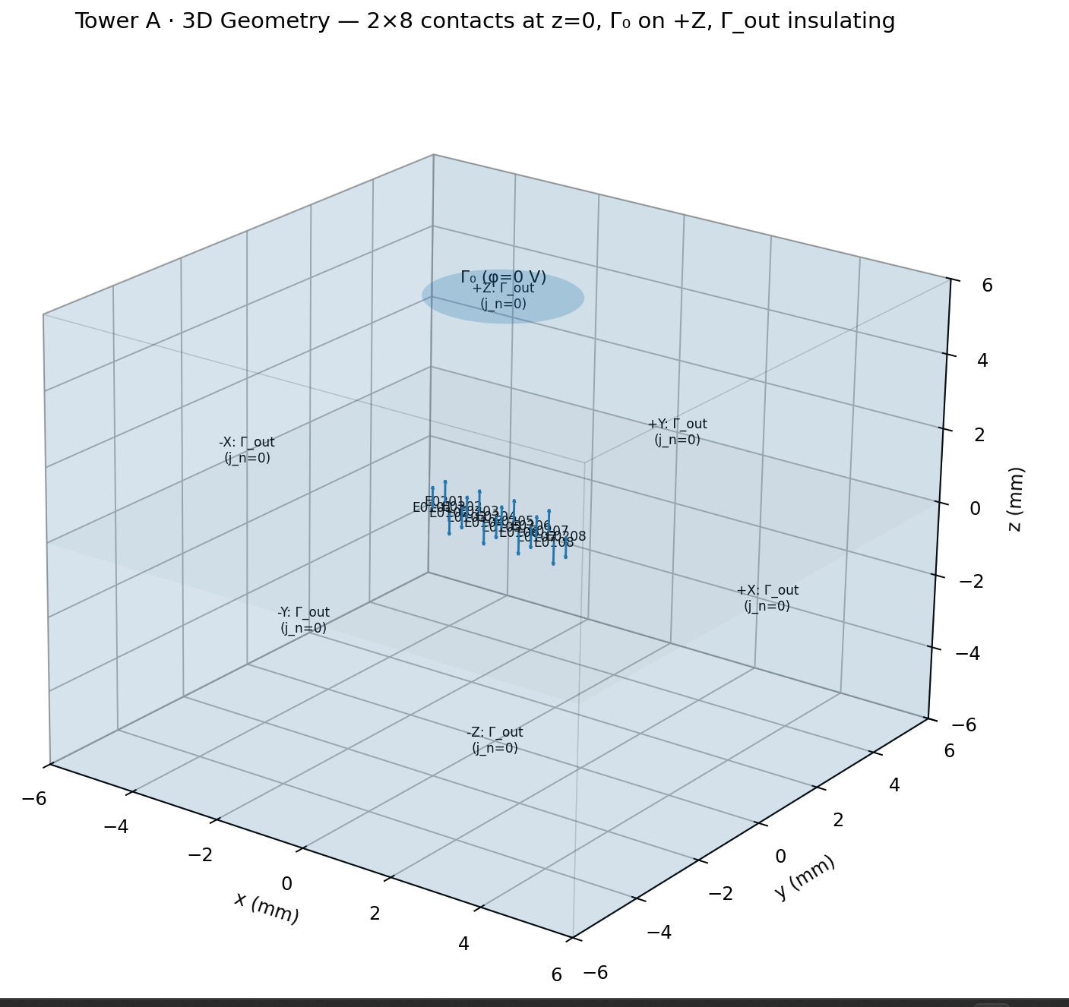
Zoomed in :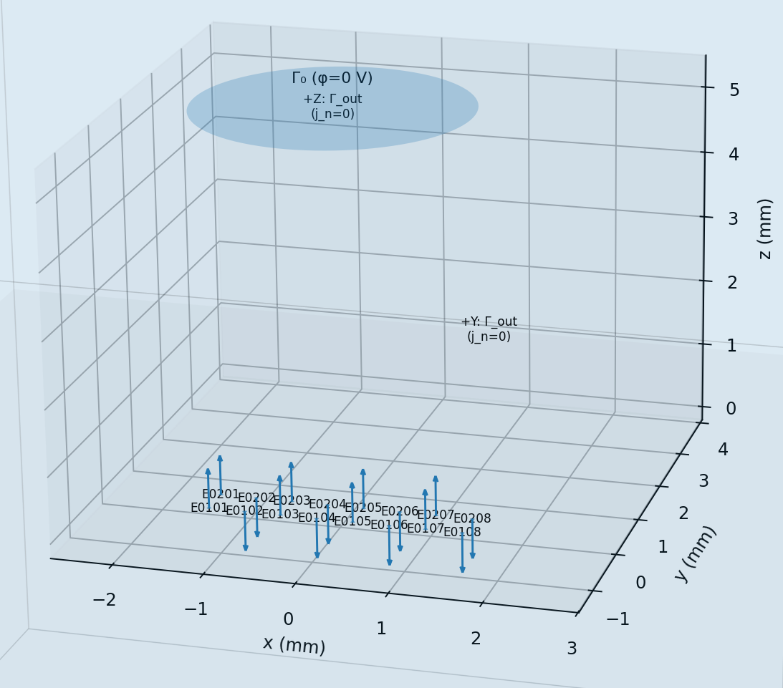
3D view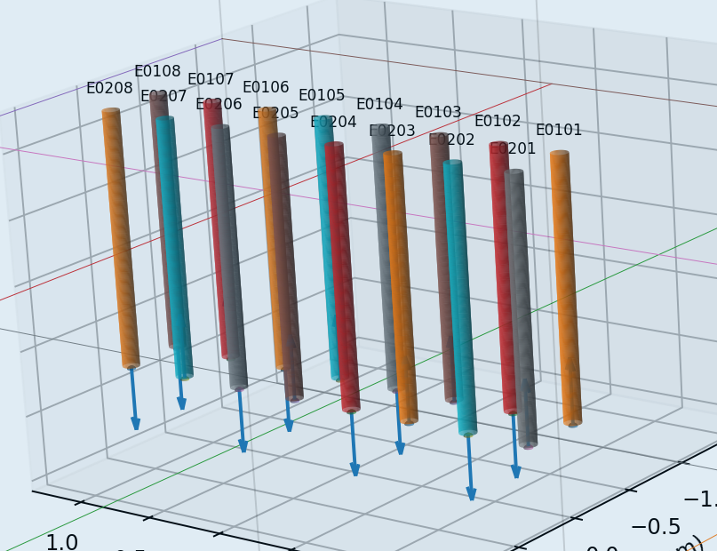

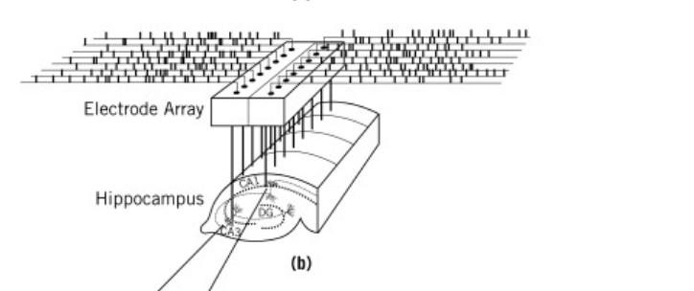

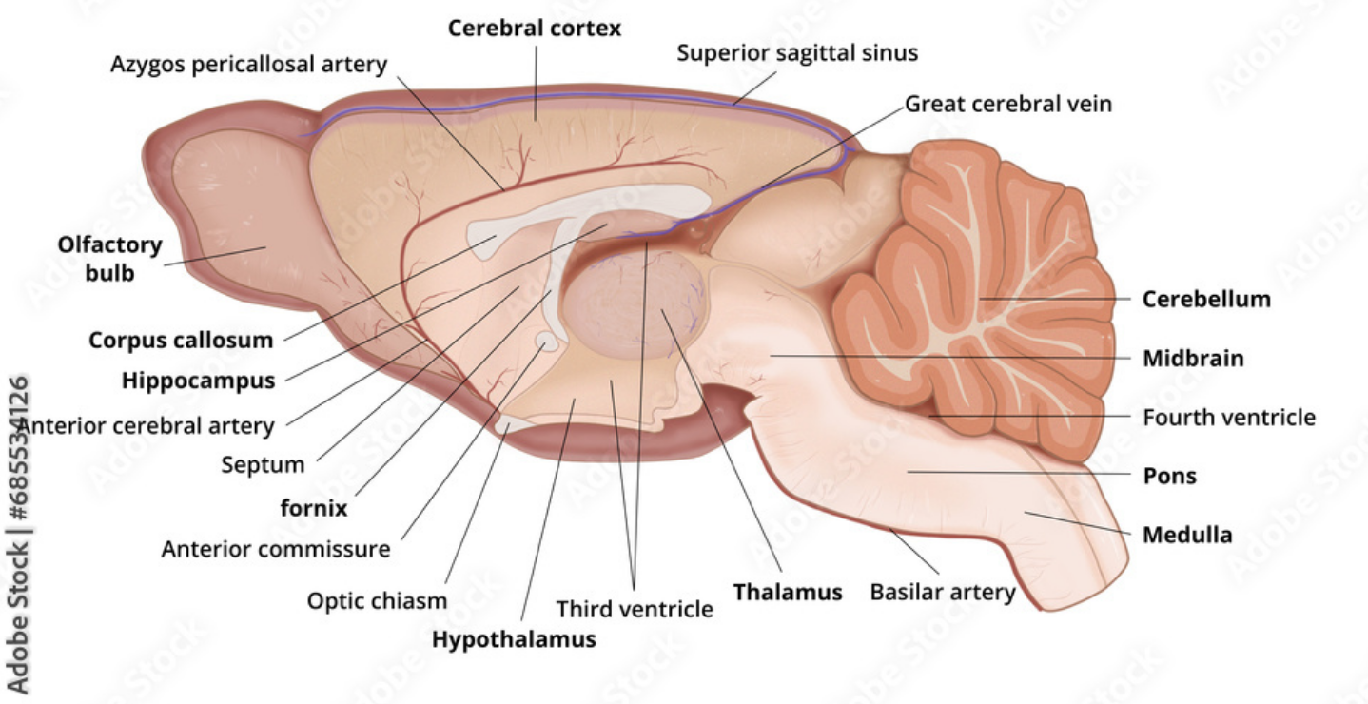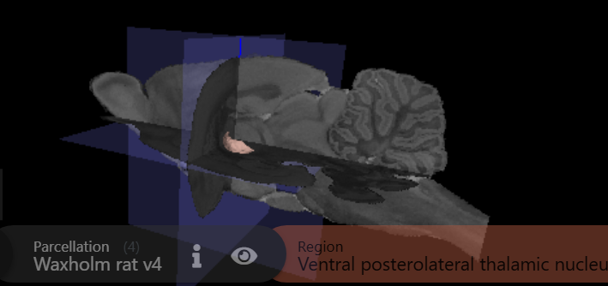
https://www.ebrains.eu/tools/rat-brain
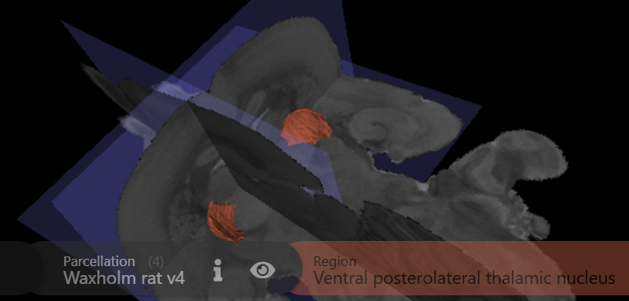

https://www.nitrc.org/projects/tpm_rat/

Length 2.6 (mm)
H 2 (mm)
W 2 mm

